**Joe Chen**

**Taiwanese Actress, Production Manager and Singer**

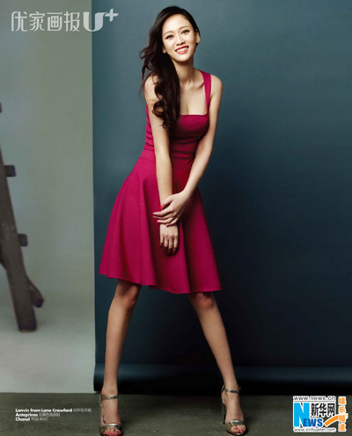

Joe Chen is one of the South East Asian actresses that have contributed to making it possible for the Asian film industry to be at par with the Western film industry although she had a poor start in her career. At the beginning of her career, in 2001, she joined a modelling outfit as an assistant and although she managed to secure a good supporting role in the 2002 television drama, *Lavender,* many people were not impressed with her performance and didn’t think she had a chance to become a star one day. She proved them wrong.

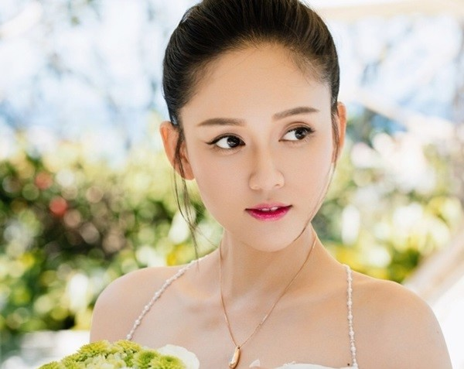

She secured a contract as a host for SET variety shows Zong *Yi Qi Jian* and *Zhong Guo Na Me Da* alongside two well established and popular Taiwanese stars namely NONO and Jacky Wu. She put up a surprising first class performance that did not go unnoticed by the producers of SET variety shows who elevated her status and provided her with the breakthrough she had been looking for with the leading role in the drama *100% Senorita* (2003). No sooner had she started than the drama shot up in the polls to become the highest rated Taiwanese drama.



From then on it was smooth sailing as she has won the hearts of millions of admirers for her adorable looks, spellbinding beauty and a fantastic screen presence. She now has, to her credit a bag full of honors and awards for her performances in several films and drama presentations. Joe Chen has also doubled successfully as a production manager, singer and TV host. All her achievements did come easy. She has come to be known as very articulate, professional and hardworking. Joe Chen works all year round, focusing most of the time on drama and is fondly referred to as the ‘Queen of Idol Dramas’.

Joe Chen is famous for her roles in films such as *Monkey King* (2014), *Youth Never Returns* (2015) and *Wangzi bian qingwa* (2015), and drama productions that include ‘*The Prince Who Turns into a Frog’* (2005)and *‘The Queen of SOP’* (2012). She started off in the Taiwanese local Television Industry but soon gained recognition in mainland Chinese entertainment market for her performance in the wuxia drama series *Swordsman* in which she played the role of an adorable person called Dongfang Bubai.

The performance earned her a massive following of Chinese fans and made her one of the most adored actresses in China. She managed, from the same drama series, *Swordsman*, to bag several awards which led to her listing on Forbes China Celebrity 100. They included China TV Drama Award, Huading Award, and the China Television Drama Quality award. The awards laid the foundation for her to get the opportunity to move on to the big screen with movies like *Our Times* and *Forever Love.* As a member of the 7-member Di Duo Hua Band she has also thrilled thousands of fans singing alongside Joyce Chao.

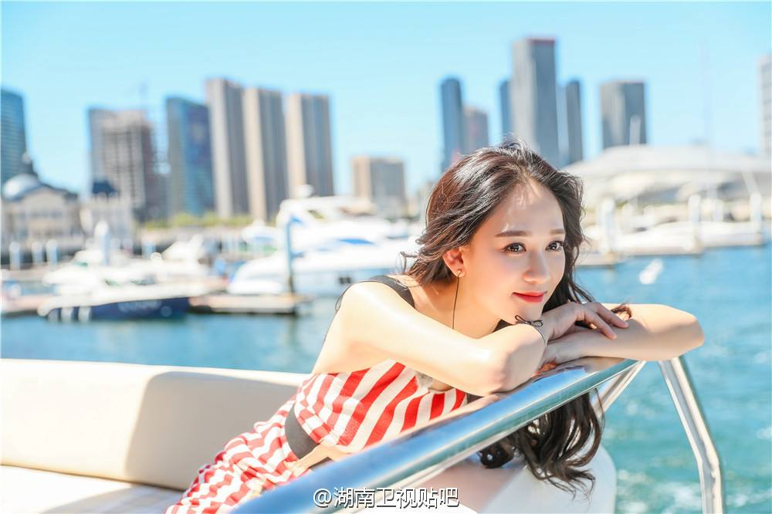

Chen is a Taiwanese, born on April 4, 1979 in Hsinchu, Taiwan. Her real name is Chiao-en Chen. She was born into a middle class family. Her parents were able to enrol her into middle and high schools that were fully equipped to offer her the appropriate learning experiences and foundation to help her achieve her childhood dreams of being an actress.

She learnt quite a lot about the nuances of acting in the schools’ theatre presentations. Outside of stage and screen performances, Joe Chen involves herself heavily in reading and writing. The passion for reading and writing, especially poetry, first emerged in her high school days in which could be seen participating fully in school recitals.

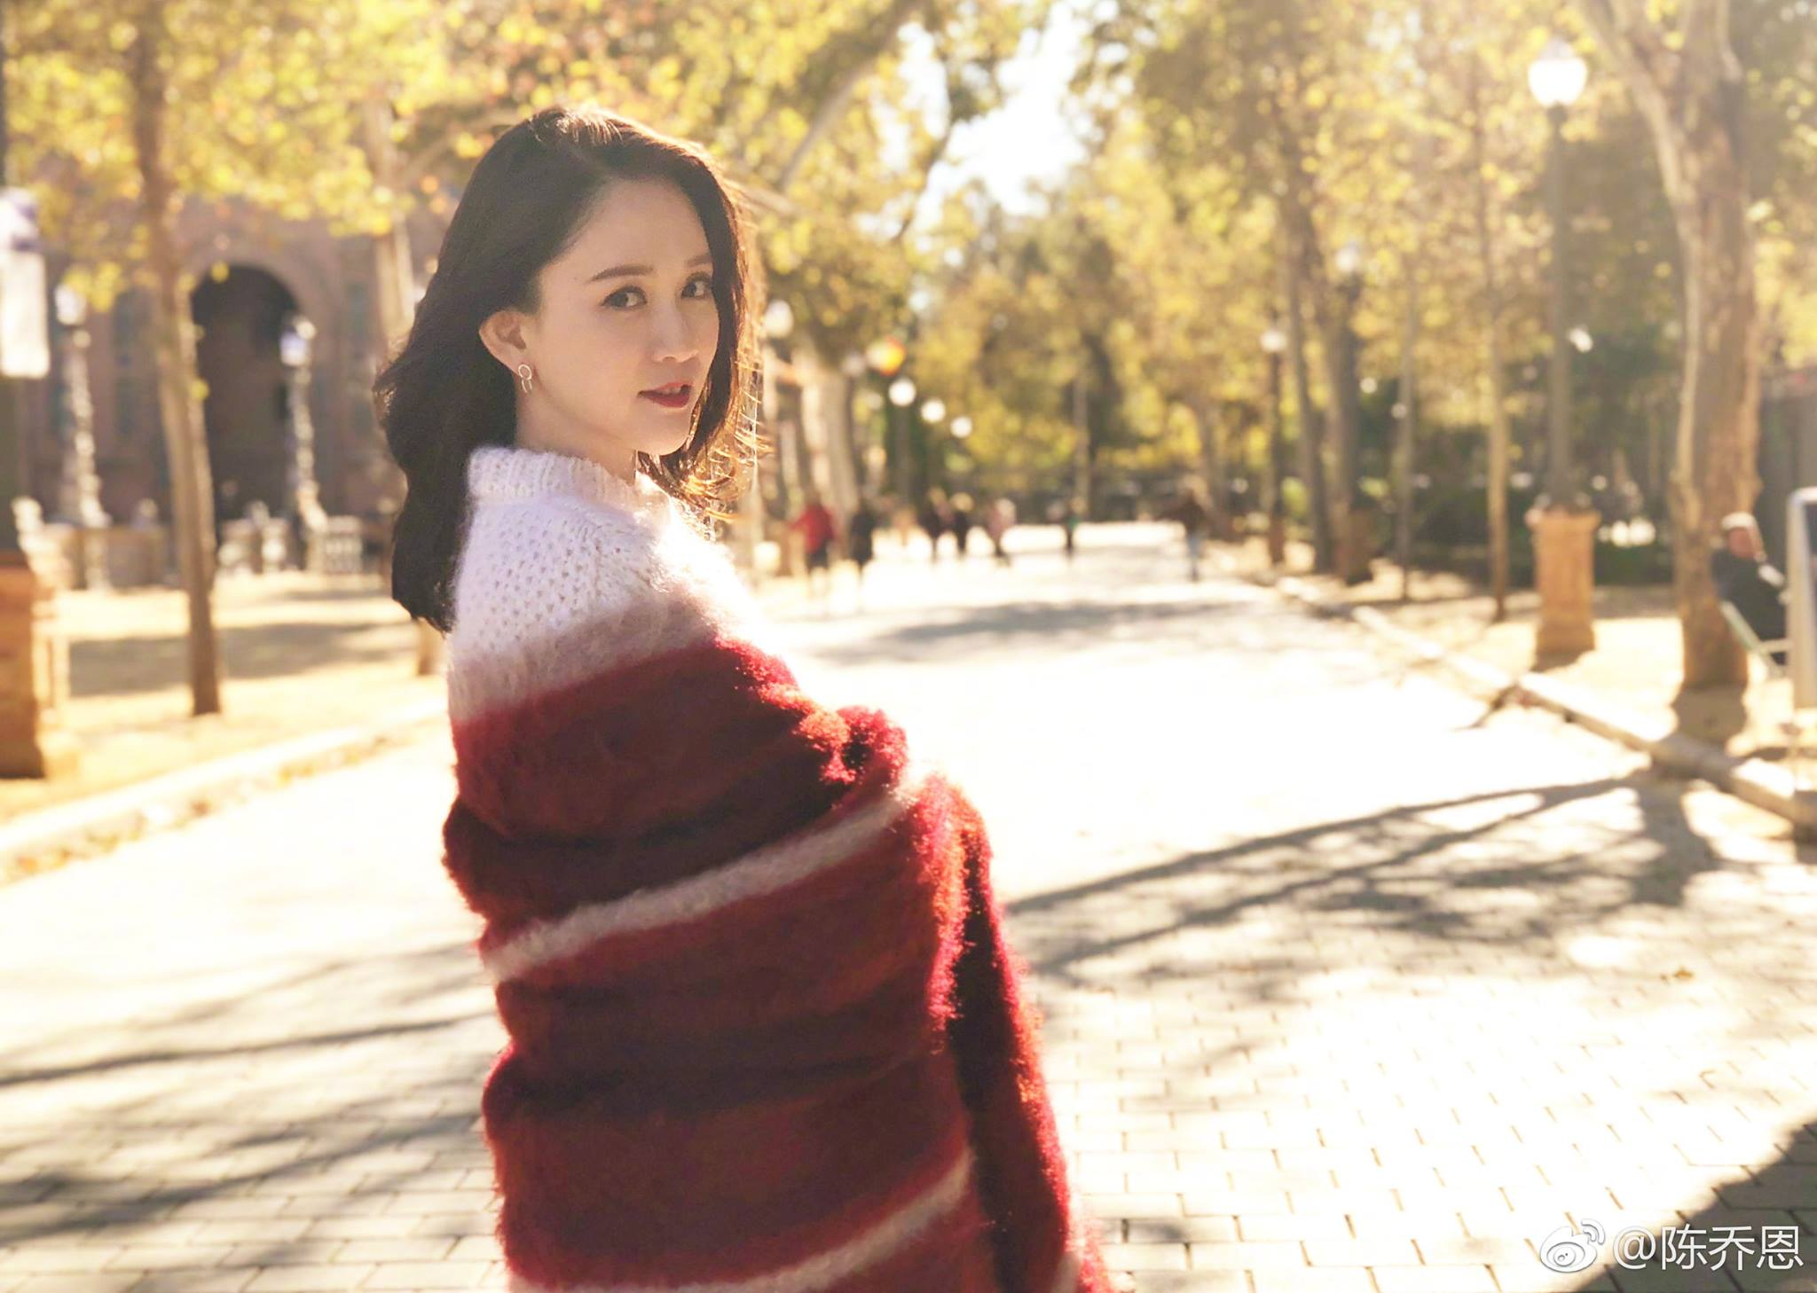

Unfortunately, with a formidable stand in the entertainment industry as an ace actress, she still attracts quite a bit of negative publicity in the media for some of her actions and inactions off stage. *Netizens* in Sept 2017 criticised her and called her “heartless” for not showing visible emotional signs on the passing of a friend and fellow actor Kimi Qiao. She has also been accused in the media of having an improper relationship with a 16-year old actor. However, Joe Chan has been able to keep up her good appearances and present a happy face at public functions.

.